**Technical Documentation – Stage Oracle Harness**

1. Job – Stages the Oracle Harness.
2. Survey – User Supplied Variables

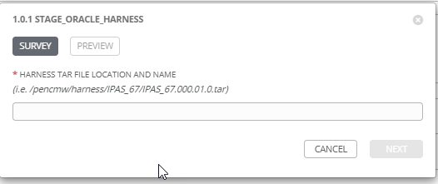

|  |  |  |  |
| --- | --- | --- | --- |
| **Survey Extra Variables** | **Prompt** | **Type** | **Description and Usage** |
| Harness_Tar_File | Harness Tar File Location and name | Text | The fully qualified tar file name to be deployed. Note that this file and location MUST be present on the staging server diagoras1bcp.penc.local.  Sample name:  /pencmw/harness/IPAS_67/IPAS_67.000.01.0.tar |

1. Jobs Used by the Job Template - http://owl.penc.local:18080/svn/deploy_automation/trunk/Ansible_PlayBooks/Harness

| **Job Template** | **Ansible Playbook** | **Project** | **Description and Usage** |
| --- | --- | --- | --- |
| 1.0.1 Stage_Oracle_Harness | stage_oracle_harness.yml | Harness | The copies the tar file from the location provided and stages it into the /opt/db_releases/stage. This location is available both on diagoras1bcp.penc.local and pdeploy1bcp.penc.local. pdeploy1bcp is used by the ESIT DBAs to deploy the harness.  No other checks are carried on file other than for its existence and that it is a regular UNIX/Linux file.  Sample Output:  Output_Text: |-  Harness Notification  IPAS_70.000.11.1.tar  ...has been staged in...  diagoras1bcp:/opt/db_releases/stage |